JDBC Practical

Write a program in Java that enters student details (Roll No, Name etc) and retrieves information. Use Access as a database and write the application in JDBC

**THEORY:**

JDBC stands for Java Database connectivity’s. It is a software layer that allows developers to write real client-server projects in Java. JDBC was designed to be a very compact, simple interface focusing on the execution of raw SQL statements and retrieving the results. The components of JDBC are Application, Driver manager and Driver.

Step 1 – Open application MySQLWorkBench 8.0 CE

1. Press add connection and type “assignment1” in connection name
2. Create new schema by press “New Schema” button in toolbox and set name to db1
3. Create table name Student by press “New Table” button in toolbox add columns id, name, department.
4. Add Some records in the table.

* Note: you should press apply after each step

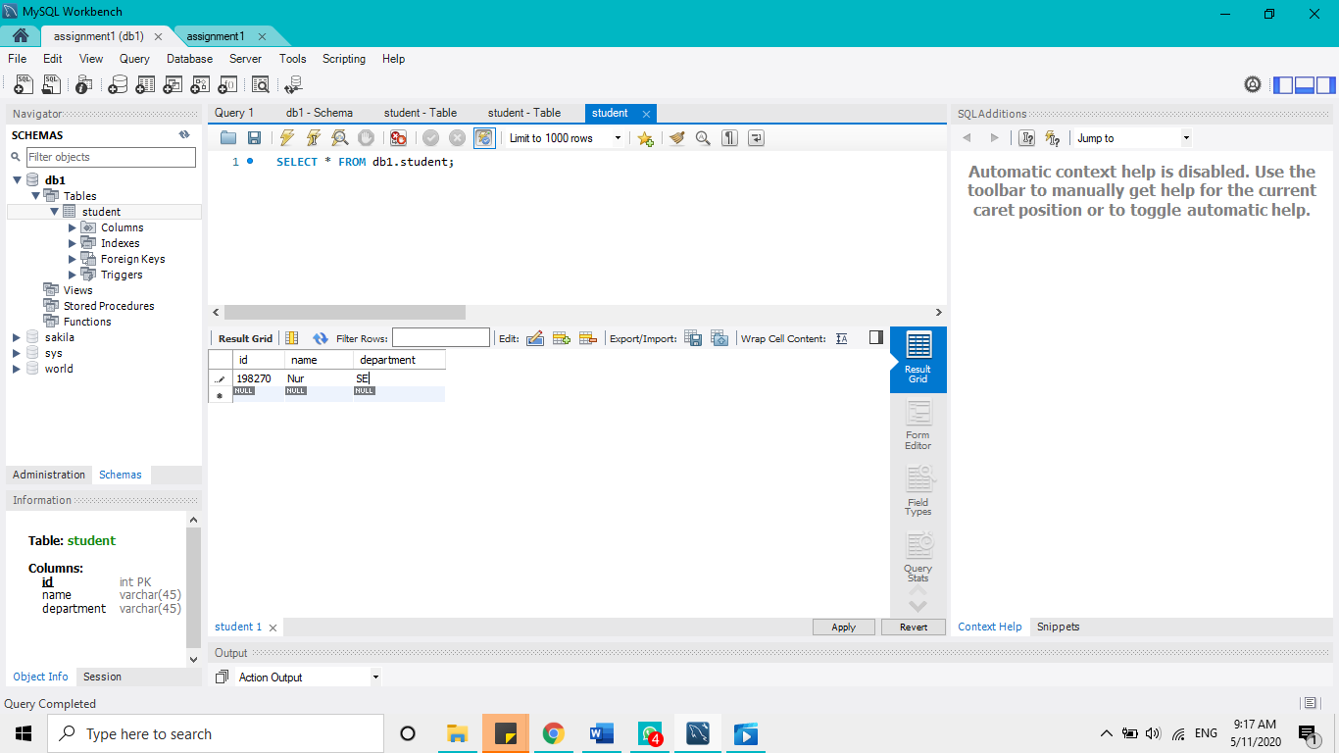

Step 2 - Create Java Project using Eclipse

Step 3 - Remove module-info under src folder

Step 4- Download MySql Driver “[mysql-connector-java-8.0.12.jar](https://repo1.maven.org/maven2/mysql/mysql-connector-java/8.0.12/mysql-connector-java-8.0.12.jar)” from <https://repo1.maven.org/maven2/mysql/mysql-connector-java/8.0.12/>

Step 5- Add MySql connector lib to your project <https://www.mysqltutorial.org/connecting-to-mysql-using-jdbc-driver/>

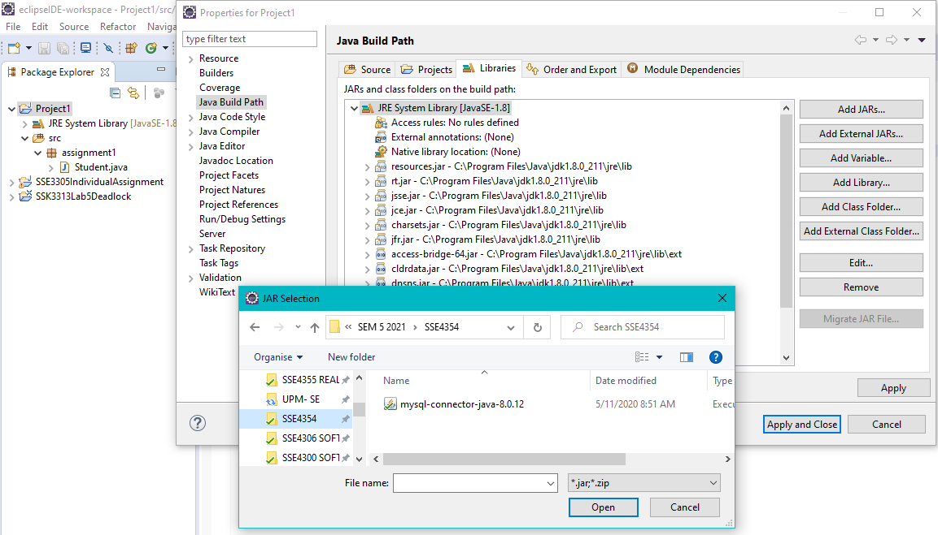

Step 6 – Create package under src folder named assignment1

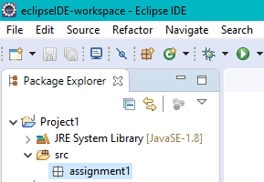

Step 7 – Create class named Student under src folder

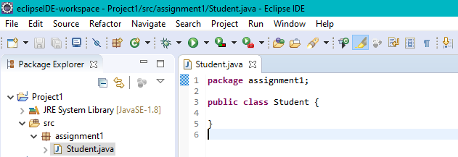

**Writing Class File:**

**package** assignment1;

**import** java.sql.*;

**public** **class** Student {

**public** **static** **void** main(String[] args) **throws** SQLException {

// Connect to database

Connection conn = **null**;

conn = DriverManager.*getConnection*("jdbc:mysql://localhost:3306/db1?" +

"user=root&password=password");

// Create a statement to retrieve objects

Statement s = conn.createStatement();

// Retrieve results from the table

ResultSet rs = s.executeQuery ("Select * from Student");

// Print columns headers

ResultSetMetaData rsmd =rs.getMetaData();

**int** i =rsmd.getColumnCount( );

**for**(**int** j=1; j<=i; j++) {

System.***out***.print(rsmd.getColumnName(j)+"\t");

System.***out***.print(" ");

}

// Print records

**while**(rs.next( ) ) {

**for**(**int** j=1; j<=i; j++)

{

System.***out***.print ( rs.getString( j)+"\t");

}

}

}

}

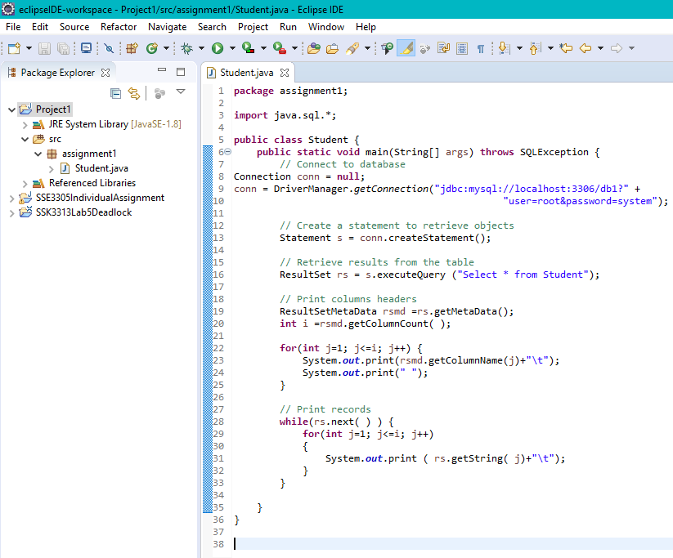

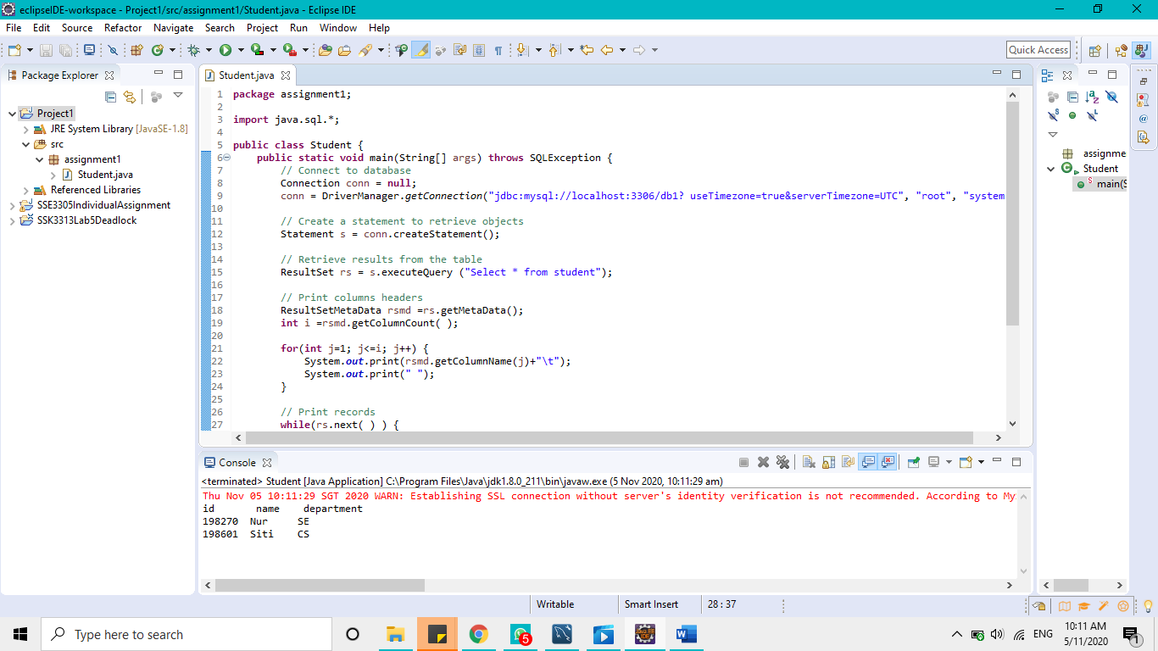

Step 8 – Upload the project to GitHub